10.55: a)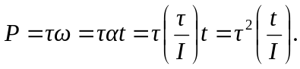
b) From the result of part (a), the power is 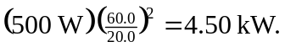
c)
d) From the result of part (c), the power is 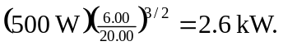 e) No; the power is proportional to the time t or proportional to the square root of the angle.

